**Understanding Mutable, Unmodifiable, and Immutable Collections in Java**

**Introduction**

Welcome to the world of Java collections! If you've ever stumbled upon the terms mutable, unmodifiable, and immutable collections, you might have felt a bit overwhelmed. Don't worry; you’re not alone. Let's unpack these concepts together in a straightforward manner, with practical examples that will help clarify their meanings and uses.

**What are Collections in Java?**

In Java, collections are a way of grouping and managing groups of objects. Think of them as containers for your data. Depending on your needs, you might want to modify that data or keep it constant. This brings us to the three types of collections we'll explore today: modifiable, unmodifiable, and immutable.

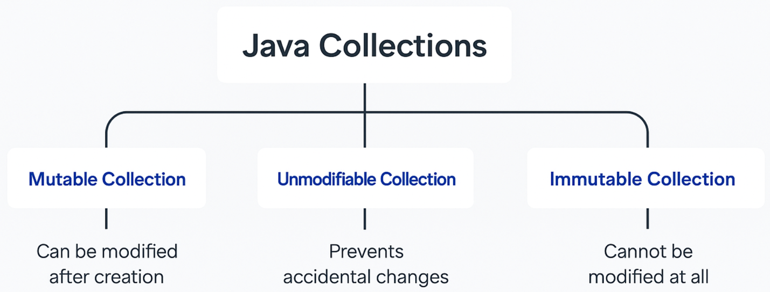

**Mutable collections**

As the name suggests, mutable collections allow you to change their contents. You can add, remove, or update elements freely. This is typically what we use when data needs to be dynamic. Here’s a simple example using an `ArrayList`:

In this snippet, we create a list of fruits. You can see how easy it is to add and remove items, making `ArrayList` a go-to choice for mutable collections.

**Unmodifiable collections**

Now, let’s shift gears and talk about unmodifiable collections. These collections are like a display case. You can look at the items inside, but you cannot change them directly. You might use an unmodifiable list when you want to protect data from accidental changes. Here’s how you can create an unmodifiable list using the `Collections.unmodifiableList()` method:

As shown, while you can create an unmodifiable view of the list, remember that if the original list changes, the unmodifiable view reflects those changes. This is a shallow copy, meaning it doesn’t create a truly immutable structure.

**Immutable collections**

In contrast to unmodifiable collections, immutable collections don't allow any modifications whatsoever. They are set in stone the moment they are created. Starting from Java 9, you can easily create an immutable list with `List.of()`:

Here, once you create an immutable list, any attempt to modify it results in an exception. This makes immutable collections perfect for situations where you need guaranteed stability and protection against changes.

**Conclusion**

To sum up our exploration of collections in Java, it's essential to understand when to use mutable, unmodifiable, and immutable types. Mutable collections give you flexibility, while unmodifiable collections prevent accidental changes, and immutable collections offer safety against any modifications at all.

By understanding these different types, you can choose the right collection based on your needs. The right choice can lead to better data integrity and fewer bugs in your applications. So, the next time you’re writing your Java code, you'll feel more confident in choosing the right collection for your task! Happy coding!